TidyVerse Tutorial In R:

Author: Ashkan Farhangi

Source: <https://cengel.github.io/R-data-wrangling/dplyr.html#add-new-columns>

# **How to use piping in R:**

Q: How can we sort, clean, and select part of dataset that is important for us in R?

A:

Use sorting, filter, and select modules from Tidyverse to ease your funcitons:

Code available in TidyVerseTut.txt File

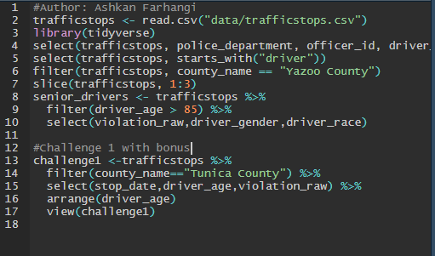

#Challenge 1 with bonus

challenge1 <-trafficstops %>%

filter(county_name=="Tunica County") %>%

select(stop_date,driver_age,violation_raw) %>%

arrange(driver_age)

view(challenge1)

Results:

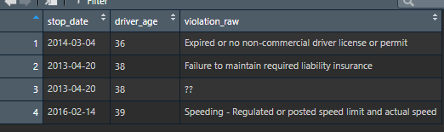

# **2 Data Mutation**

Q: How can you create a new column based on an exsiting data?

we’ll use mutate() for create a new copy from a column, keep the original and change the new one as we like.

Code:

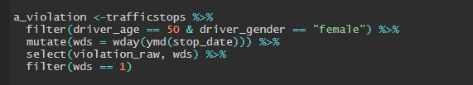

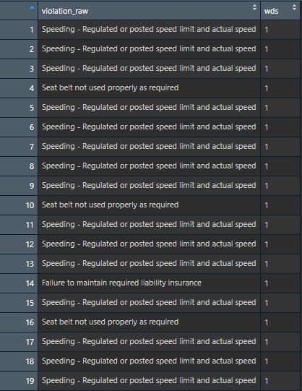

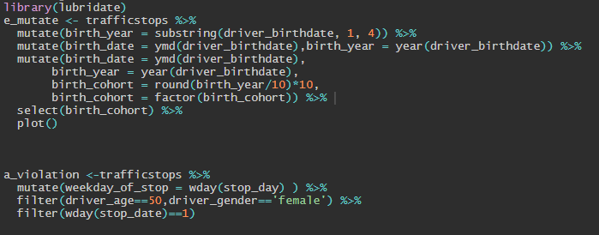

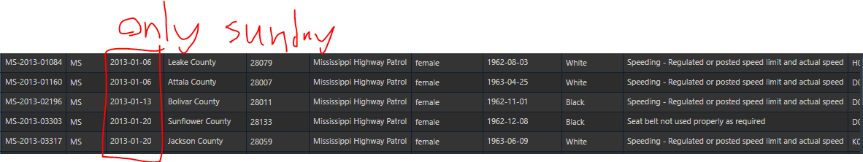

**Joining two or more tables**

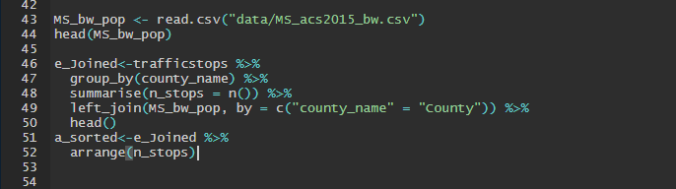

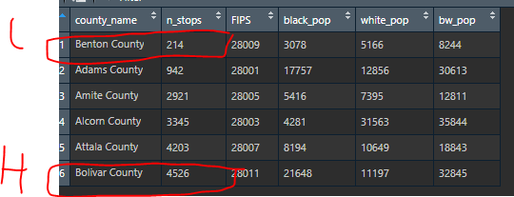

**Wide vs Long Format**

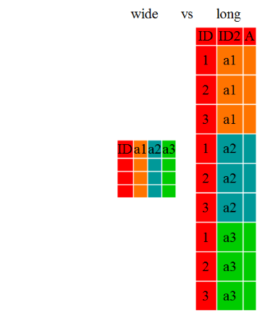

For problem 1 It’s a **long** format.

# **Data Manipulation**

